 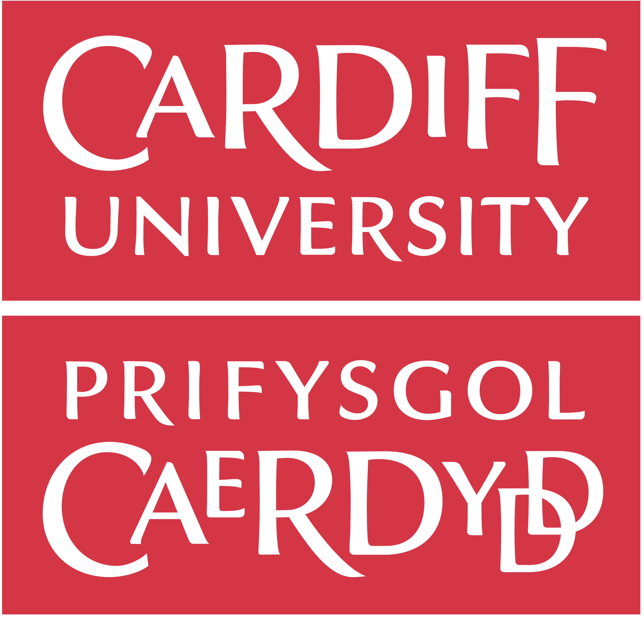

**International Workshop:**

**APPLICATION FORM**

**UK PI:** Prof. Antonio A. R. Ioris, Cardiff University

**Brazil PI:** Prof. Vitale Joanoni Neto, UFMT and IFMT

**Main Disciplines Involved** (it will be a highly interdisciplinary workshop)**:** geography, history, anthropology, economics, environmental studies, development studies, agriculture, etc.

**Dates and venue:** Federal Institute of Mato Grosso, campus Alta Floresta (IFMT), with additional activities at the Federal University of Mato Grosso (UFMT), campi Cuiabá and Sinop, between **6-12 July 2025**.

The International Science Partnerships Fund (ISPF) is designed to enable potential and foster

prosperity through research and innovation partnerships by supporting UK researchers and

innovators to work with peers around the world on the major themes of our time: planet, health,

tech, and talent.

In the framework of our ISPF alliance with the Amazonia+10 initiative, the Amazonia BR/UK workshops programme, which aims to support the research and academic environment through bilateral collaboration between the UK and Brazil, is **now recruiting early career researchers to participate in the UK-Brazil interdisciplinary workshop on Socio-ecological Questions and Bioeconomic Alternatives.**

The workshop will provide a unique opportunity for sharing research expertise and networking. During the workshops early career researchers will have the opportunity to present their research in the form of a poster and short oral presentation and discuss this with established researchers from the UK and partner countries. There will be a focus on building up partnership for future collaborations and participants selected on the basis of their research potential and ability to build long term links.

The ISPF/British Council **will cover the costs related to the participation to the workshop, including travel (both international and local), accommodation and meals**. Costs for the visa, and travel insurance will be covered; however, participants will be responsible for making the necessary arrangements. ISPF/British Council, Cardiff University, UFMT and IFMT accept no responsibility for any problems which may occur with travel or accommodation arrangements or any other issues participants might experience when the participants are away from their home.

**Application and Deadline:**

The full application below must be completed and submitted by British and Brazilian applicants (i.e. researchers based and working in the UK or in Brazil), together with an updated 2-page CV, by **15 April 2025** to **iorisa@cardiff.ac.uk** and **vitale.neto@ufmt.br**

**Eligibility Criteria:**

* Applications must be submitted using the application form below.
* Application must be submitted before the deadline (15 April 2025).
* Participants must be Early Career Researchers: Early Career Researchers are defined as holding a PhD (or having equivalent research experience) and having up to 10 years post-PhD research experience. They are equivalent to the ‘Recognised Researcher’ and sometimes ‘Experienced Researcher’ categories in the EU framework for researchers’ careers. https://euraxess.ec.europa.eu/europe/career-development/training-researchers/research-profiles-descriptors.
* Participants must have a research or academic position (a permanent post, research contract or fellowship etc.) at a recognised research institution either in the UK or in Brazil. Please note that participants are expected to attend all sessions of the workshop.
* Fluent English language skills (Brazilian applicants must provide a recent IELTS with 6.5 overall and a minimum of 5.5 in each of the subskills; in special situations, equivalent international certificates or English school qualifications, as well as two peer-reviewed publications in English, could be considered).

**Quality Assessment**

* Experience and relevance of the applicant’s research area to the workshop.
* Motivation and contribution to the aims of the workshop.
* Description of the long term impact expected through the participation in the workshop.
* Ability to disseminate workshop’s outcomes.

**Selection Procedure:**

* Eligibility check
* Quality assessment

**Notification of application results:**

Applicants will be notified by email at least 45 days prior to the workshop.

**Equal Opportunities**

Equal opportunities and diversity are at the heart of the British Council’s cultural relations ambitions. While recognising that some research fields are dominated by one particular gender, co-ordinators are encouraged to work towards an equal gender balance, promote diversity. They must not exclude applicants on the basis of ethnicity, gender, religious belief, sexual orientation, social status or disability. Participants’ selection undertaken by workshop organisers must not contravene this policy. Extra support to enable participation of Early Career Researchers with special needs will be given.

|  |  |
| --- | --- |
| Workshop Application Form | |
| **1. Applicant** | |
| Name and title |  |
| Gender (for statistical purposes. This will not affect choice of participants) |  |
| Position and institution |  |
| Postal address |  |
| Email |  |
| Phone number |  |
| Summary of carrier, achievements, publications, markers of esteem, and any other relevant information – no more than 250 words |  |

|  |
| --- |
| **2. Abstract -** Please give a summary of your area of research and your contribution so far. |
|  |

|  |
| --- |
| **3. Please describe your motivation for attending the workshop and how the workshop matches your professional development needs.** |
|  |

|  |
| --- |
| **4. Please describe the expected impact of your participation on your personal and professional development, including your ability to work internationally.** |
|  |

|  |
| --- |
| **5. Please indicate how you will disseminate the outcomes of the workshops and the new knowledge/skills you have acquired** |
|  |

|  |  |  |  |
| --- | --- | --- | --- |
| **6. Workshops will take place in English as standard. Please, if you are a non-native English speaker, indicate your ability to work and communicate in English** | | | |
| Native speaker |  | Good |  |
| Excellent |  | Need support |  |

|  |
| --- |
| **7. Please use this space to give any additional information that you feel is relevant for the application. Note that travel details will be arranged after the selection process.** |
|  |

Please send your CV with this application form to both [iorisa@cardiff.ac.uk](mailto:iorisa@cardiff.ac.uk) and to [vitale.neto@ufmt.br](mailto:vitale.neto@ufmt.br) by 15 April 2025.